Day73&74 - Challenge10 - Terraform Challenge01

1. Create an EC2 Instance on AWS Cloud using the below-mentioned ubuntu AMI and instance_type. Or, (You can use of your choice as well) ami = "ami-0461b1436c9b3c1a3" instance_type = "t3.micro"
Step-1: Create a Terraform folder
- You already have: …\Terraform\ec2
Step-2: Create main.tf
Open the folder in VS Code.
- Create a file: main.tf
provider "aws" {
region = "us-east-1"
}
resource "aws_instance" "my_ec2" {
ami = "ami-025d99823a4caad37"
instance_type = "t3.micro"
tags = {
Name = "Terraform-EC2"
}
}
- Save the file.
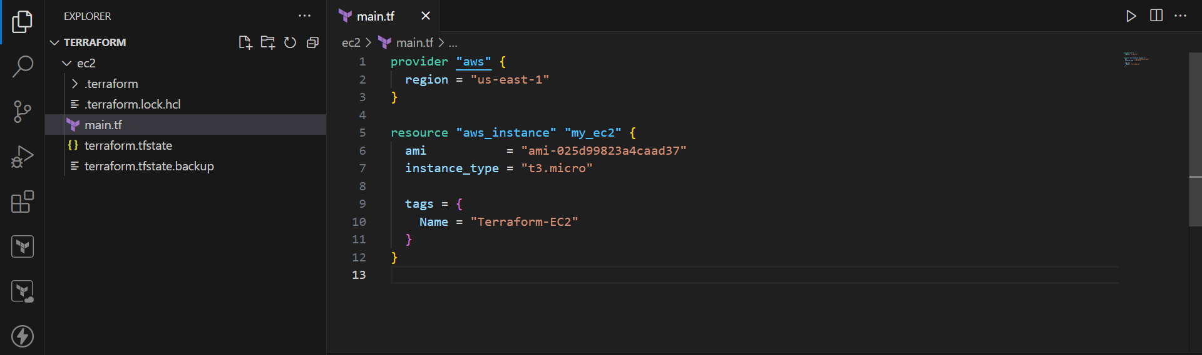
Step-3: Check AWS credentials
Before Terraform creates anything, make sure your AWS CLI is connected to your AWS account.
- Run: aws sts get-caller-identity
You should get output containing your AWS account information.
If this works, continue.
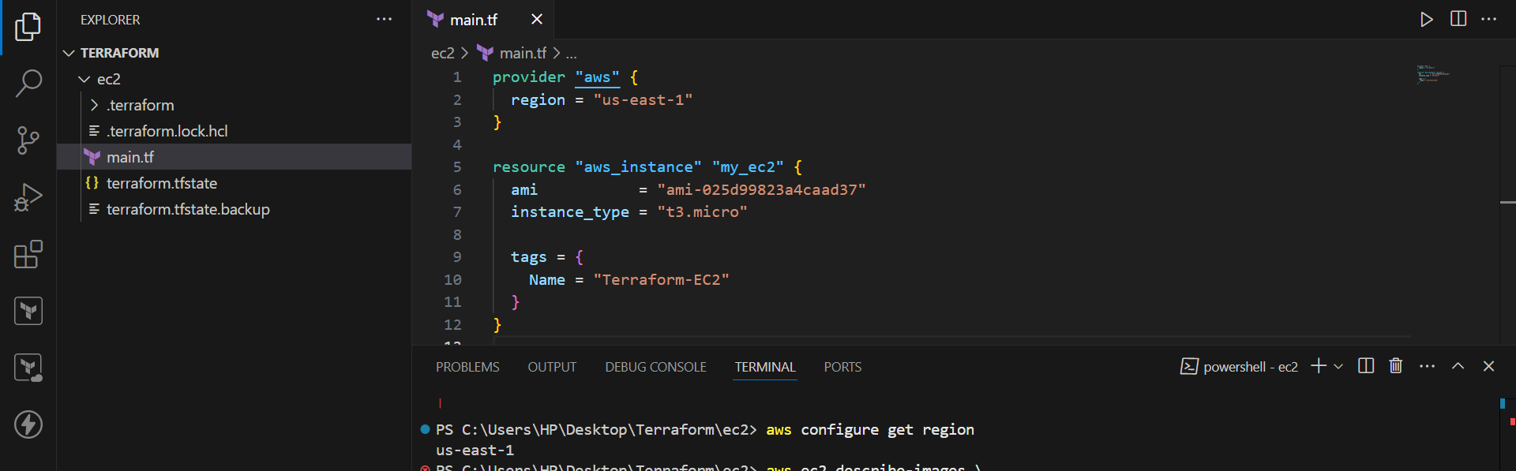
Step-4: Initialize Terraform
- Run: terraform init
Terraform downloads the AWS provider.
You should see: Terraform has been successfully initialized!
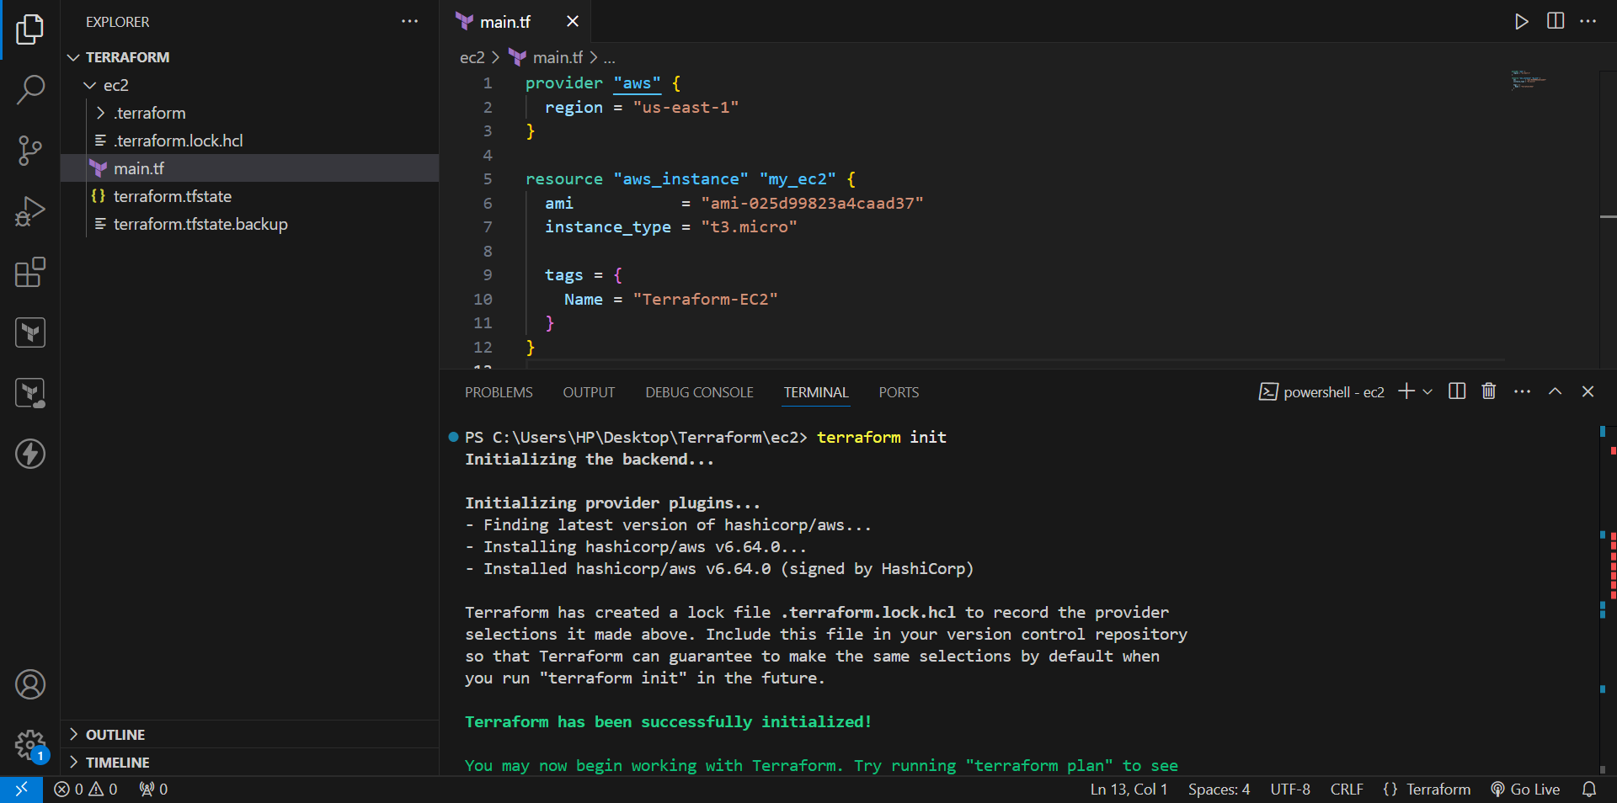
Step-5: Create the EC2 instance
- Run: terraform apply
Terraform will ask: Do you want to perform these actions?
Only 'yes' will be accepted to approve.
- Enter: yes
Terraform will now create your EC2 instance.
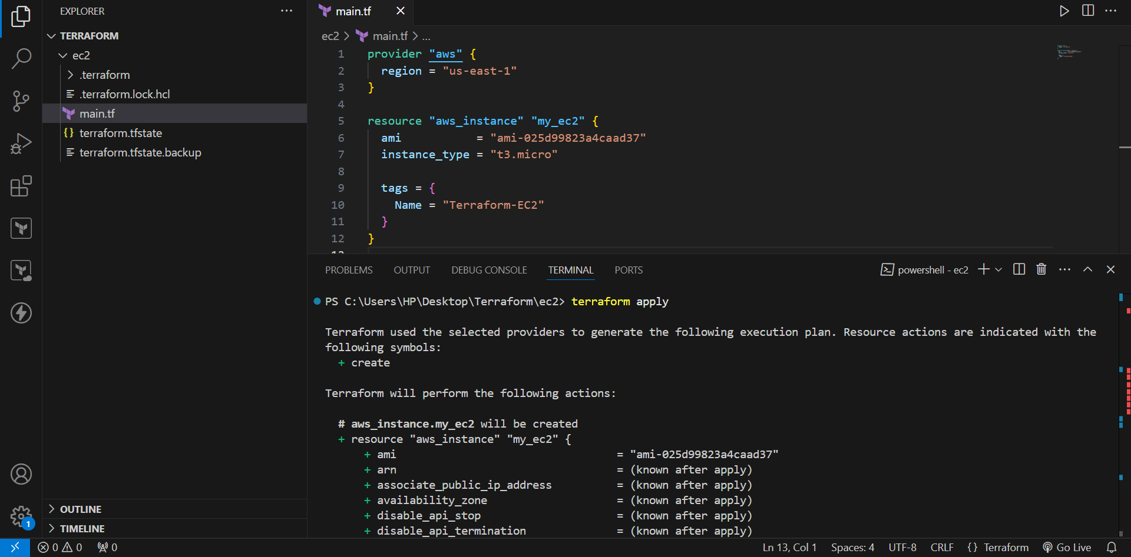
Step-6: Verify in AWS Console
Go to: AWS Console → EC2 → Instances
Look for:
Name: Terraform-EC2
Instance type: t3.micro
AMI: Ubuntu 24.04
Region: us-east-1
State: Running
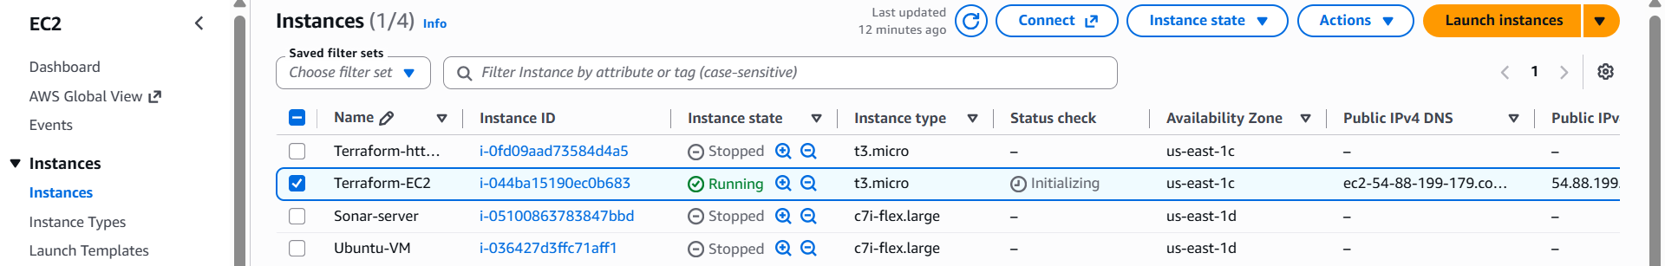
Step-7: Verify using AWS CLI
You can also check the instance from PowerShell:
- Run, aws ec2 describe-instances --region us-east-1 --query "Reservations[].Instances[].{ID:InstanceId,State:State.Name,Type:InstanceType,AMI:ImageId}" --output table
You should see your instance ID, running state, t3.micro, and your AMI ID.
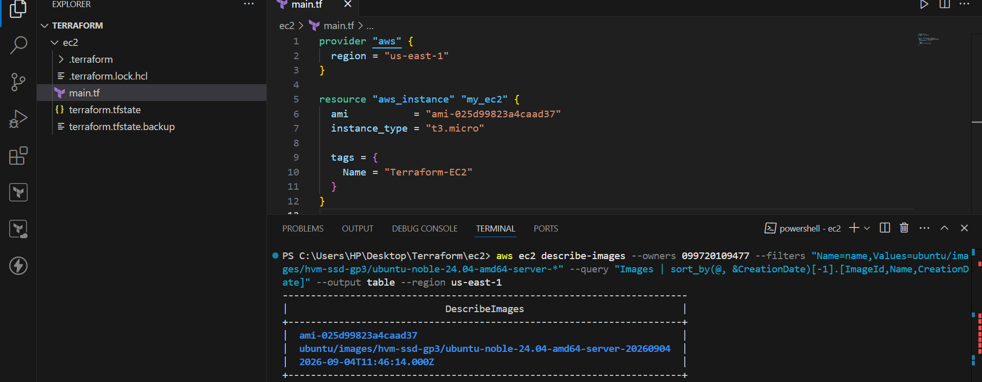
2. Install a web server on the same EC2 Instance. The web server should listen on port 8080.
Step-1: Go to your Terraform folder
Open PowerShell: …\Terraform\ec2
Check that your Terraform file exists: dir
You should see: main.tf
Step-2: Put the Terraform code in main.tf
Open main.tf in VS Code and use this code:
provider "aws" {
region = "us-east-1"
}
resource "aws_security_group" "web_sg" {
name = "terraform-web-sg"
description = "Allow SSH and web traffic"
ingress {
description = "SSH"
from_port = 22
to_port = 22
protocol = "tcp"
cidr_blocks = ["0.0.0.0/0"]
}
ingress {
description = "Web Server"
from_port = 8080
to_port = 8080
protocol = "tcp"
cidr_blocks = ["0.0.0.0/0"]
}
egress {
from_port = 0
to_port = 0
protocol = "-1"
cidr_blocks = ["0.0.0.0/0"]
}
tags = {
Name = "Terraform-Web-SG"
}
}
resource "aws_instance" "my_ec2" {
ami = "ami-025d99823a4caad37"
instance_type = "t3.micro"

security_groups = [aws_security_group.web_sg.name]
user_data = <<-EOF
#!/bin/bash
apt update -y
apt install apache2 -y
sed -i 's/Listen 80/Listen 8080/' /etc/apache2/ports.conf
sed -i 's/<VirtualHost \\*:80>/<VirtualHost *:8080>/' /etc/apache2/sites-enabled/000-default.conf
cat > /var/www/html/index.html <<'HTML'
<html>
<head>
<title>Terraform EC2 Web Server</title>
</head>
<body>
<h1>Hello from Terraform EC2</h1>
<p>Apache is running on port 8080.</p>
</body>
</html>
HTML
systemctl restart apache2
systemctl enable apache2
EOF
tags = {
Name = "Terraform-EC2-WebServer"
}
}
Save the file.
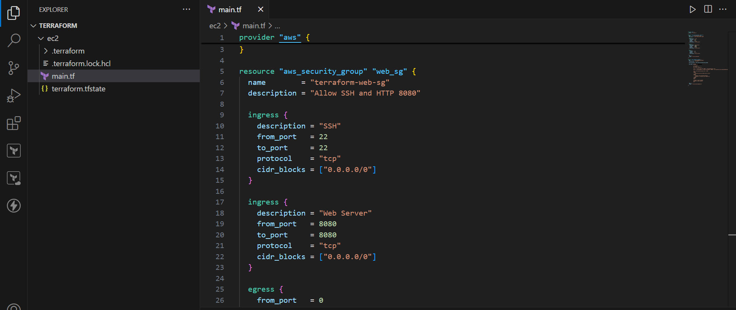
Step-3: Check AWS credentials
- Run: aws sts get-caller-identity
You should get your AWS account information.
If this command works, Terraform can use your AWS credentials.
Step-4: Initialize Terraform
- Run: terraform init
This downloads the AWS provider.
Expected: Terraform has been successfully initialized!
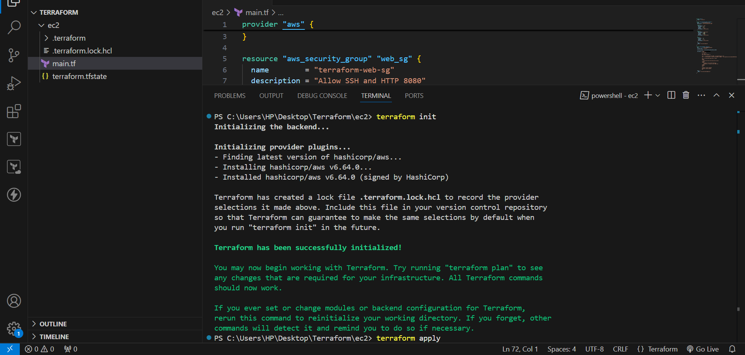
Step-5: Create the infrastructure
- Run: terraform apply
- Terraform will ask: Do you want to perform these actions?
Only 'yes' will be accepted to approve.
- Type: Yes
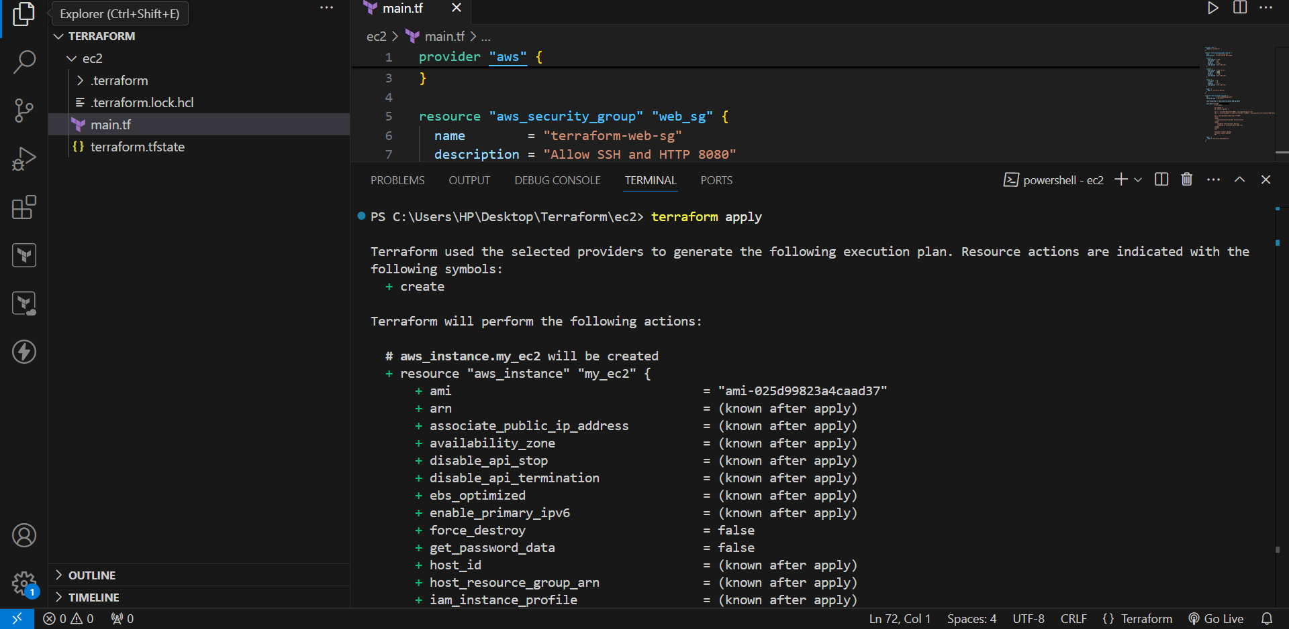
Step-6: Find the EC2 public IP
Go to: AWS Console → EC2 → Instances
- Find: Terraform-EC2-WebServer
Click the instance.
- Find: Public IPv4 address
For example: 54.123.45.67
Your IP will be different.
Step 11: Check the Security Group
Go to: EC2 → Instances → Your Instance → Security
Find the Security Group.
- Under Inbound rules, you should see:
Type Port
--------------------
SSH 22
- Custom TCP 8080
The 8080 rule is required so that people outside the EC2 can access Apache.
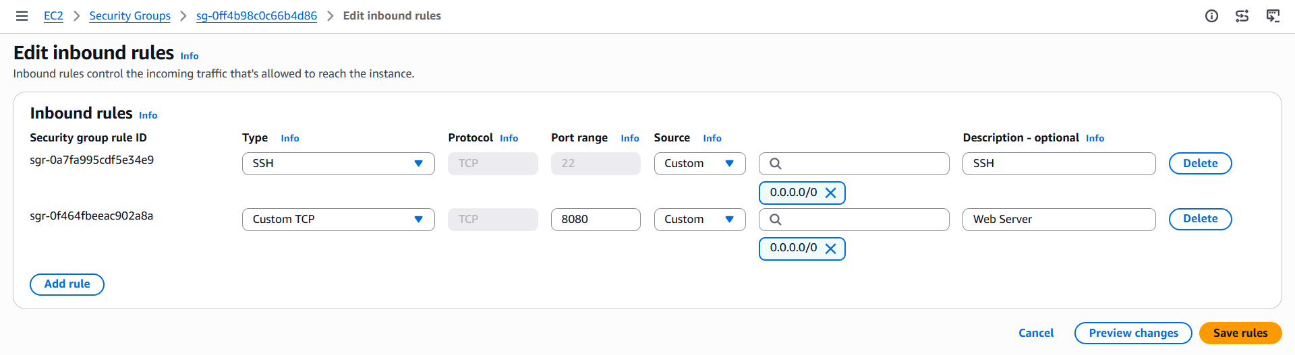
Step-12: Open the web server
Open your browser.
- Use: http://YOUR-PUBLIC-IP:8080
- For example: http://54.123.45.67:8080
- You should see: Hello from Terraform EC2
Apache is running on port 8080.
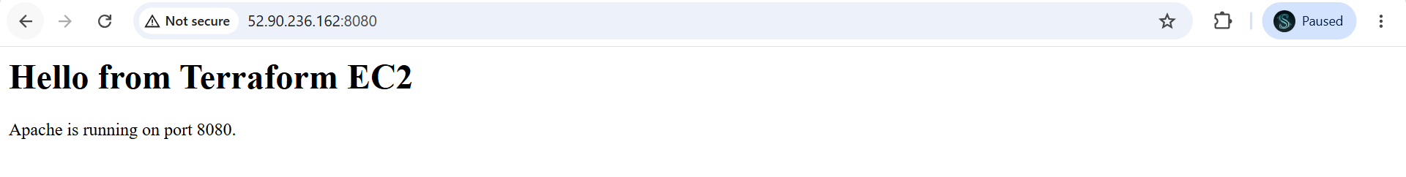
3. Create a Docker-compose file for the project:https://github.com/betawins/cricbuzz-docker-hello-world.gitand point it to port 8000.
Step-1: Create Terraform Project
- Create a Terraform directory.
- For example: mkdir …\Terraform\ec2
Go into the directory: cd …\Terraform\ec2
- Create: main.tf
Step-2: Configure AWS Provider
In main.tf, configure the AWS provider:
provider "aws" {
region = "us-east-1"
}
This tells Terraform to create AWS resources in the US East (N. Virginia) region.
Step-3: Create Security Group
We need to allow:
- SSH – port 22
- Application – port 8000
Terraform configuration:
resource "aws_security_group" "docker_sg" {
name = "terraform-docker-sg"
description = "Allow SSH and application port 8000"
ingress {
description = "SSH"
from_port = 22
to_port = 22
protocol = "tcp"
cidr_blocks = ["0.0.0.0/0"]
}
ingress {
description = "Application"
from_port = 8000
to_port = 8000
protocol = "tcp"
cidr_blocks = ["0.0.0.0/0"]
}
egress {
from_port = 0
to_port = 0
protocol = "-1"
cidr_blocks = ["0.0.0.0/0"]
}
tags = {
Name = "Terraform-Docker-SG"
}
}
Step-4: Complete Terraform Code
- Your final main.tf should contain:
provider "aws" {
region = "us-east-1"
}
resource "aws_security_group" "docker_sg" {
name = "terraform-docker-sg"
description = "Allow SSH and application port 8000"
ingress {
description = "SSH"
from_port = 22
to_port = 22
protocol = "tcp"
cidr_blocks = ["0.0.0.0/0"]
}
ingress {
description = "Application"
from_port = 8000
to_port = 8000
protocol = "tcp"
cidr_blocks = ["0.0.0.0/0"]
}
egress {
from_port = 0
to_port = 0
protocol = "-1"
cidr_blocks = ["0.0.0.0/0"]
}
tags = {
Name = "Terraform-Docker-SG"
}
}
resource "aws_instance" "docker_ec2" {
ami = "ami-025d99823a4caad37"
instance_type = "t3.micro"
key_name = "Terraform-key"
security_groups = [aws_security_group.docker_sg.name]
user_data = <<-EOF
#!/bin/bash
apt update -y
apt install -y docker.io docker-compose-v2 git
systemctl enable docker
systemctl start docker
mkdir -p /opt/cricbuzz
git clone https://github.com/betawins/cricbuzz-docker-hello-world.git /opt/cricbuzz
cat > /opt/cricbuzz/Dockerfile <<'DOCKERFILE'
FROM golang:1.24 AS builder
WORKDIR /app
COPY go.mod go.sum ./
RUN go mod download
COPY . .
RUN CGO_ENABLED=0 GOOS=linux GOARCH=amd64 go build -o hello_world .
FROM ghcr.io/vincetse/scratch
COPY --from=builder /app/hello_world /hello_world
ENV GIN_MODE=release
EXPOSE 8080
CMD ["/hello_world"]
DOCKERFILE
cat > /opt/cricbuzz/docker-compose.yml <<'COMPOSE'
services:
app:
build: .
ports:
- "8000:8080"
COMPOSE
cd /opt/cricbuzz
docker compose up -d --build
EOF
tags = {
Name = "Terraform-Cricbuzz-Docker"
}
}

- output "public_ip"
{
value = aws_instance.docker_ec2.public_ip
}
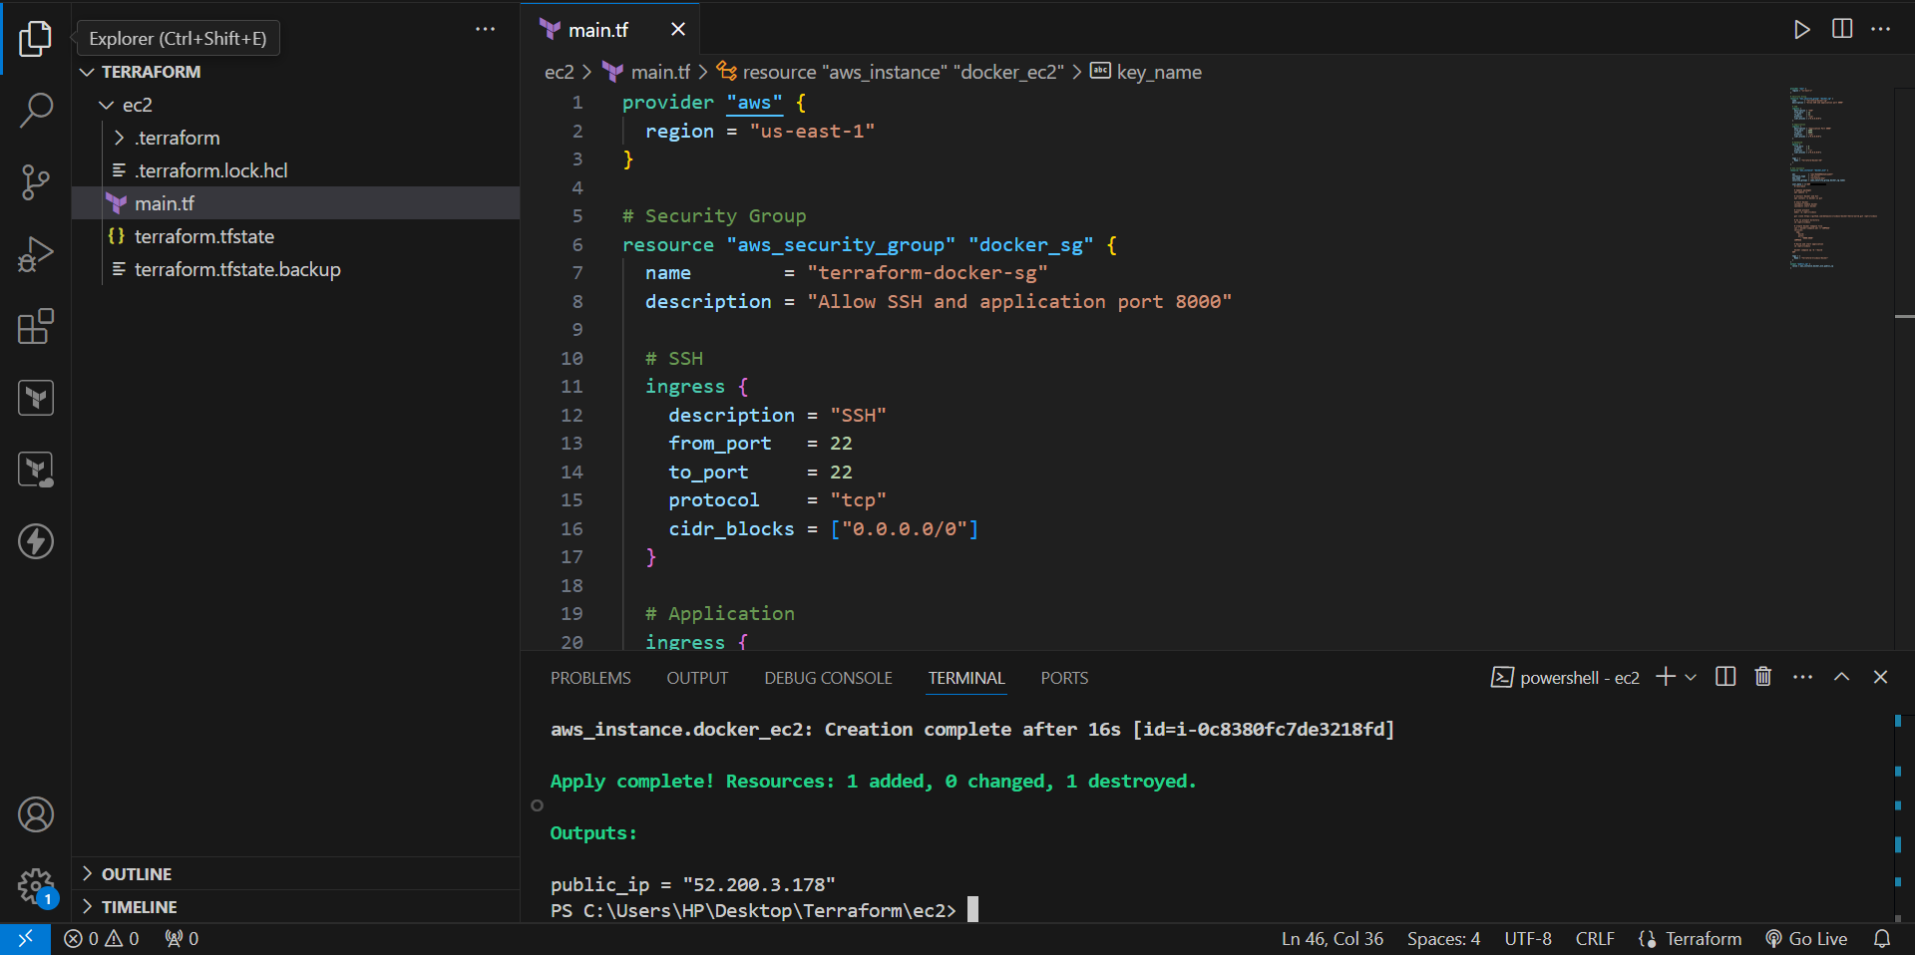
Step-5: Initialize Terraform
- Open PowerShell in the Terraform directory: terraform init
- Expected: Terraform has been successfully initialized!
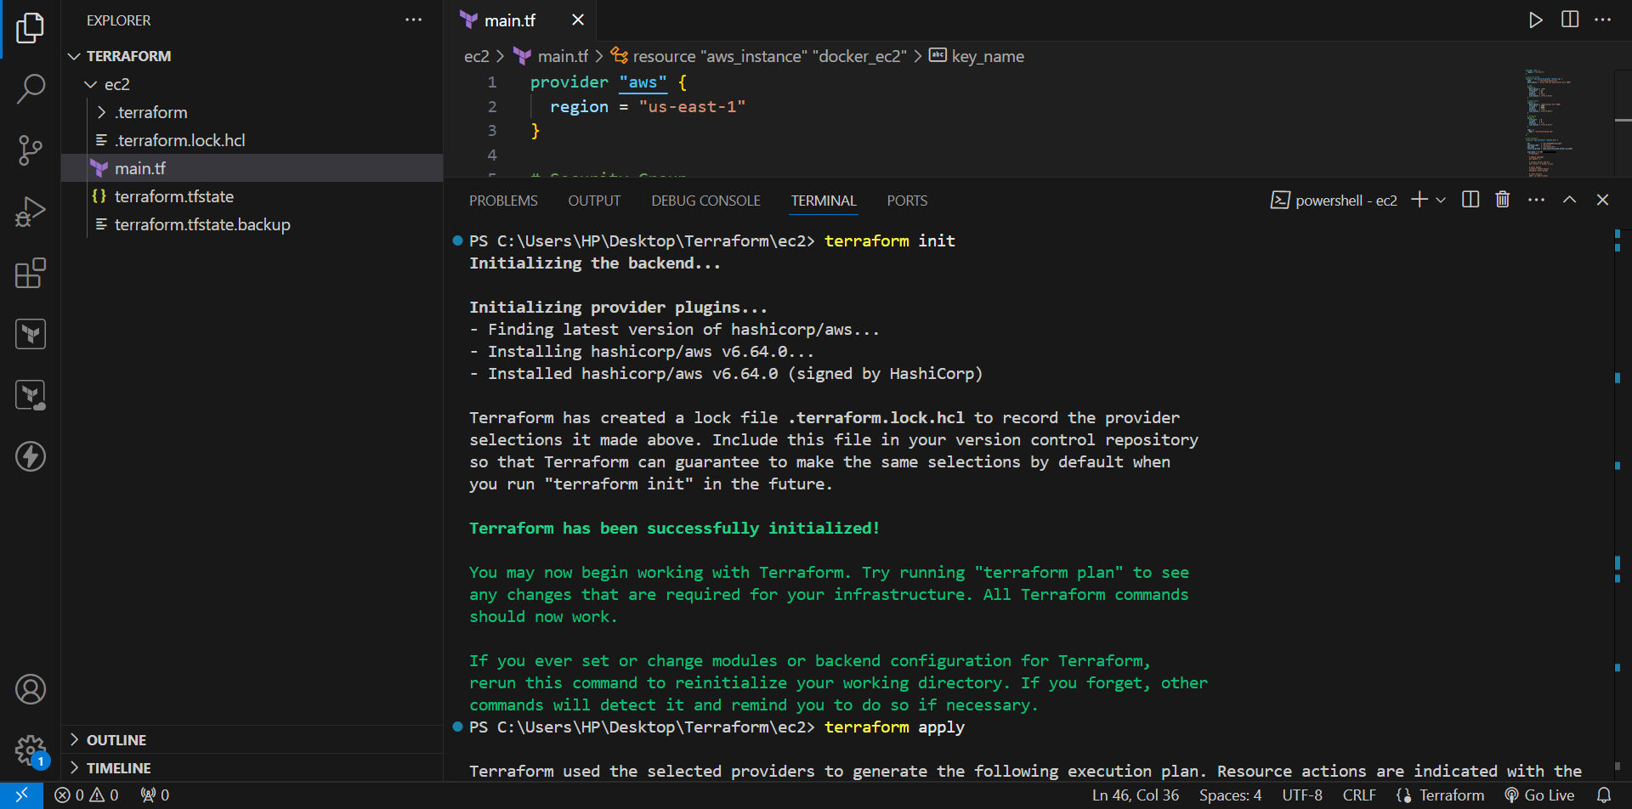
Step-6: Create Terraform Plan
- Run: terraform plan
Terraform shows what resources it will create.
- Expected: Plan: 2 to add, 0 to change, 0 to destroy.
The resources are:
- 1. aws_security_group.docker_sg
- 2. aws_instance.docker_ec2
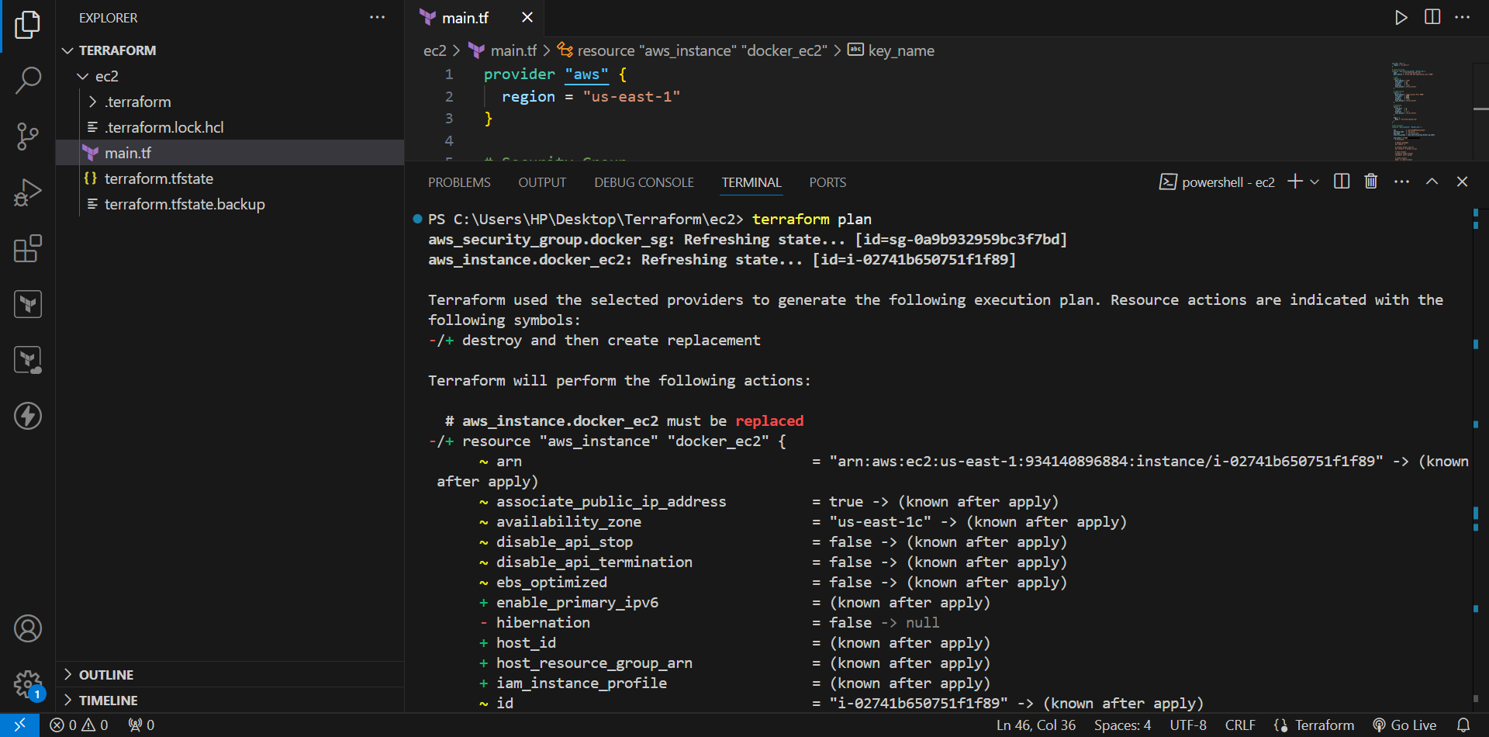
Step-7: Create Infrastructure
- Run: terraform apply
Terraform asks: Do you want to perform these actions?
- Enter: yes
Terraform creates the EC2 instance and security group.
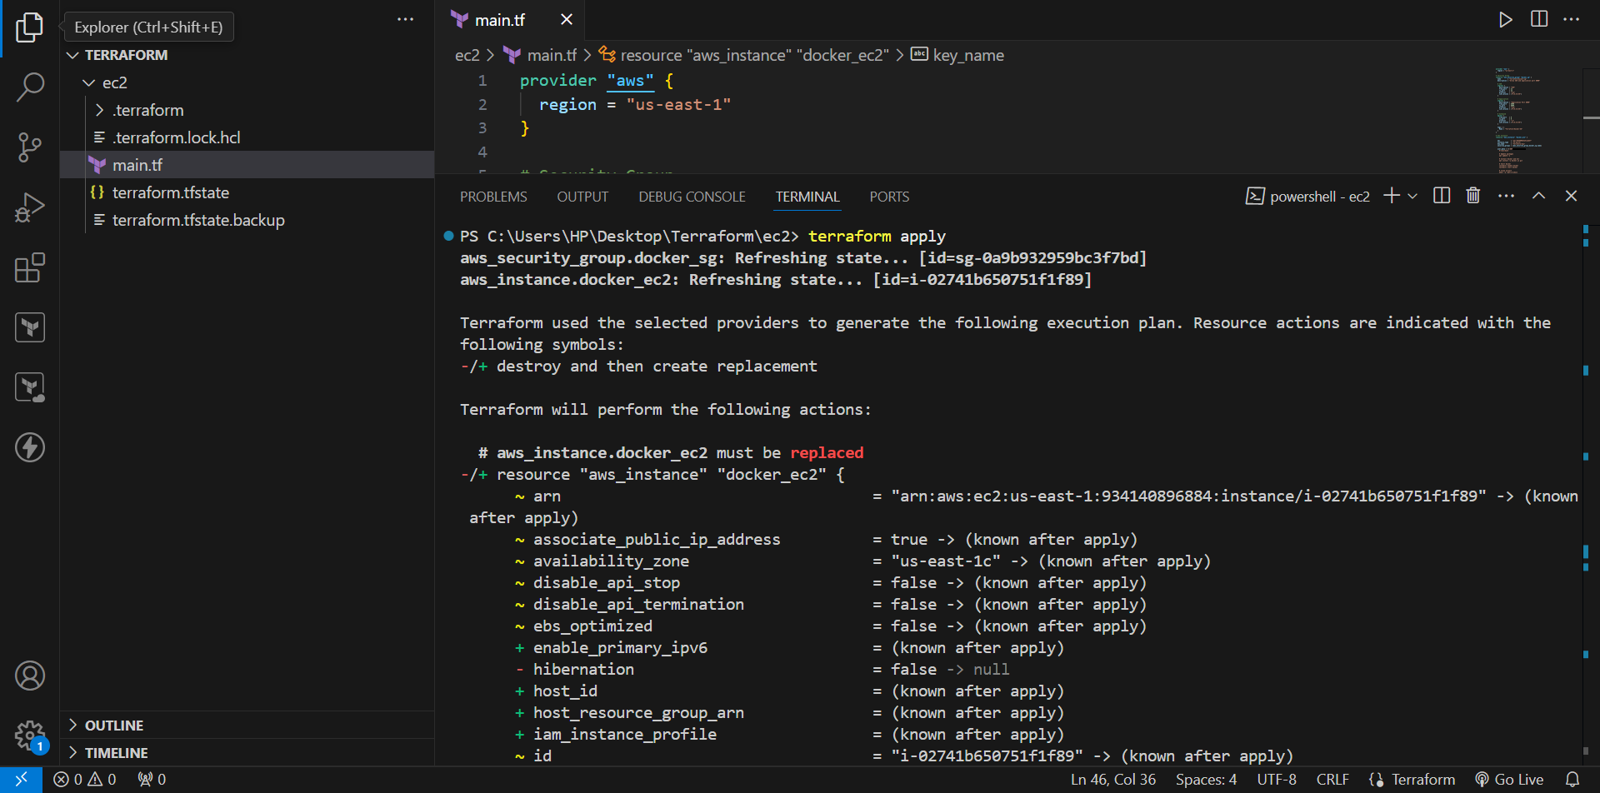
Step-8: Get EC2 Public IP
- After Terraform completes: terraform output
- Example: public_ip = "52.200.3.178"
Step-9: Connect to EC2
- Use the Terraform key: ssh -i ".../Downloads/Terraform-key.pem" ubuntu@52.200.3.178
Step-10: Verify Docker
- Run: docker --version
- Then: docker compose version
Example: Docker Compose version 2.40.3
This confirms Docker Compose is installed.
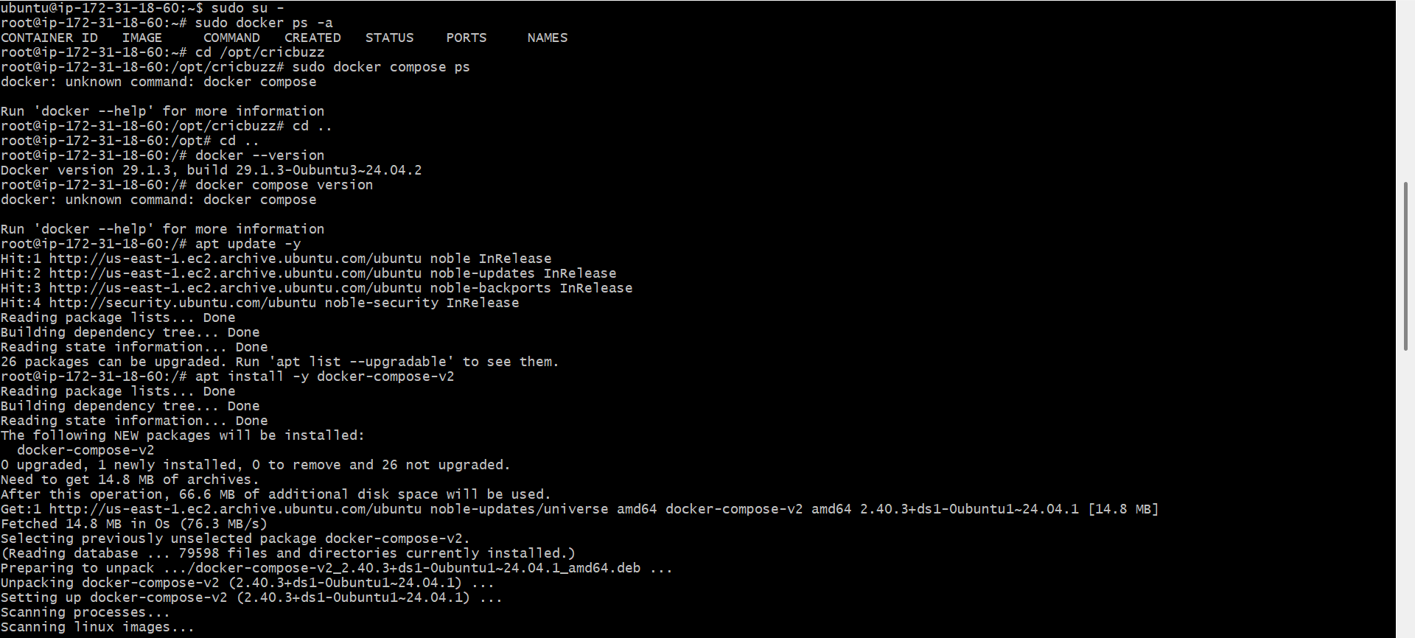
Step-11: Verify Project
Go to the project directory: cd /opt/cricbuzz
Check the files: ls
You should see: Dockerfile
docker-compose.yml
go.mod
go.sum
hello_world.go
Verify Docker Compose Configuration
Run:
cat docker-compose.yml
Expected:
services:
app:
build: .
ports:
- "8000:8080"
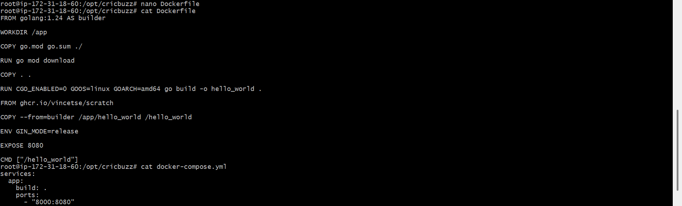
Build and Start Container
Run:
docker compose up -d --build
This builds the Go application and starts the container.

21. Verify Container
Run:
docker compose ps
Expected:
NAME IMAGE COMMAND SERVICE STATUS
cricbuzz-app-1 cricbuzz-app "/hello_world" app Up
Most importantly, check:
0.0.0.0:8000->8080/tcp
This confirms port mapping.
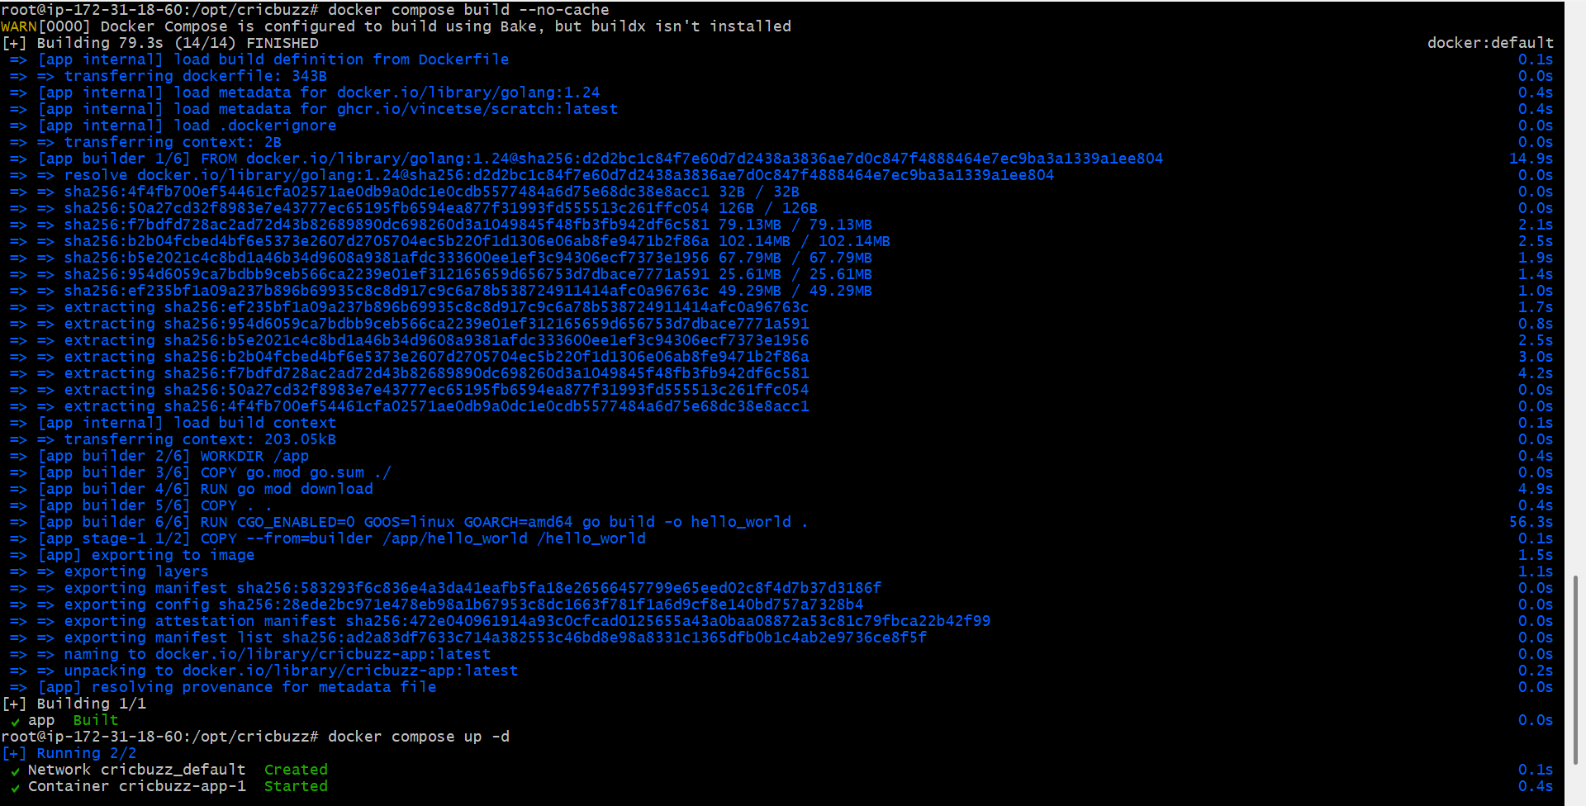
Test Application from Browser
Open:
http://52.200.3.178:8000
Replace 52.200.3.178 with your current Terraform public IP.
Expected result:
Hello, World!
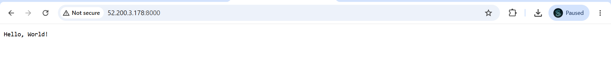
Make the web server point to the above service so that 8080 returns the response from the Docker service.
Open your Terraform project
On your Windows machine:
cd C:\Users\HP\Desktop\Terraform\ec2
Check your files:
dir
You should have:
main.tf
Step 2: Update the Security Group
Open main.tf in VS Code.
Find:
resource "aws_security_group" "docker_sg" {
Make sure you have an ingress rule for 8080:
ingress {
description = "Nginx Web Server"
from_port = 8080
to_port = 8080
protocol = "tcp"
cidr_blocks = ["0.0.0.0/0"]
}
This allows users to access:
http://EC2-PUBLIC-IP:8080
Install Nginx through Terraform
Inside your EC2 user_data, make sure this command exists:
apt install -y docker.io docker-compose-v2 git nginx
This installs:
- Docker
- Docker Compose
- Git
- Nginx
Step 4: Start Nginx
Inside user_data:
systemctl enable nginx
systemctl start nginx
Complete Terraform Example
Your Terraform structure will look like this:
provider "aws" {
region = "us-east-1"
}

resource "aws_security_group" "docker_sg" {
name = "terraform-docker-nginx-sg"
description = "Allow SSH and Nginx port 8080"

ingress {
description = "SSH"
from_port = 22
to_port = 22
protocol = "tcp"
cidr_blocks = ["0.0.0.0/0"]
}

ingress {
description = "Nginx Web Server"
from_port = 8080
to_port = 8080
protocol = "tcp"
cidr_blocks = ["0.0.0.0/0"]
}

egress {
from_port = 0
to_port = 0
protocol = "-1"
cidr_blocks = ["0.0.0.0/0"]
}

tags = {
Name = "Terraform-Docker-Nginx-SG"
}
}

resource "aws_instance" "docker_ec2" {
ami = "ami-025d99823a4caad37"
instance_type = "t3.micro"
key_name = "Terraform-key"

security_groups = [aws_security_group.docker_sg.name]

user_data = <<-EOF
#!/bin/bash

# Update packages
apt update -y

# Install Docker, Docker Compose, Git and Nginx
apt install -y docker.io docker-compose-v2 git nginx

# Start Docker
systemctl enable docker
systemctl start docker

# Start Nginx
systemctl enable nginx
systemctl start nginx

# Clone application
mkdir -p /opt/cricbuzz

git clone https://github.com/betawins/cricbuzz-docker-hello-world.git /opt/cricbuzz

# Create Dockerfile
cat > /opt/cricbuzz/Dockerfile <<'DOCKERFILE'
FROM golang:1.24 AS builder

WORKDIR /app

COPY go.mod go.sum ./

RUN go mod download

COPY . .

RUN CGO_ENABLED=0 GOOS=linux GOARCH=amd64 go build -o hello_world .

FROM ghcr.io/vincetse/scratch

COPY --from=builder /app/hello_world /hello_world

ENV GIN_MODE=release

EXPOSE 8080

CMD ["/hello_world"]
DOCKERFILE

# Create Docker Compose file
cat > /opt/cricbuzz/docker-compose.yml <<'COMPOSE'
services:
app:
build: .
ports:
- "8000:8080"
COMPOSE

# Start Docker application
cd /opt/cricbuzz
docker compose up -d --build

# Configure Nginx reverse proxy
cat > /etc/nginx/sites-available/cricbuzz <<'NGINX'
server {
listen 8080;

location / {
proxy_pass http://127.0.0.1:8000;

proxy_set_header Host $host;
proxy_set_header X-Real-IP $remote_addr;
proxy_set_header X-Forwarded-For $proxy_add_x_forwarded_for;
proxy_set_header X-Forwarded-Proto $scheme;
}
}
NGINX

# Enable Nginx configuration
ln -s /etc/nginx/sites-available/cricbuzz /etc/nginx/sites-enabled/cricbuzz

# Remove default configuration
rm -f /etc/nginx/sites-enabled/default

# Test and restart Nginx
nginx -t
systemctl restart nginx
EOF

tags = {
Name = "Terraform-Cricbuzz-Nginx"
}
}

output "public_ip" {
value = aws_instance.docker_ec2.public_ip
}
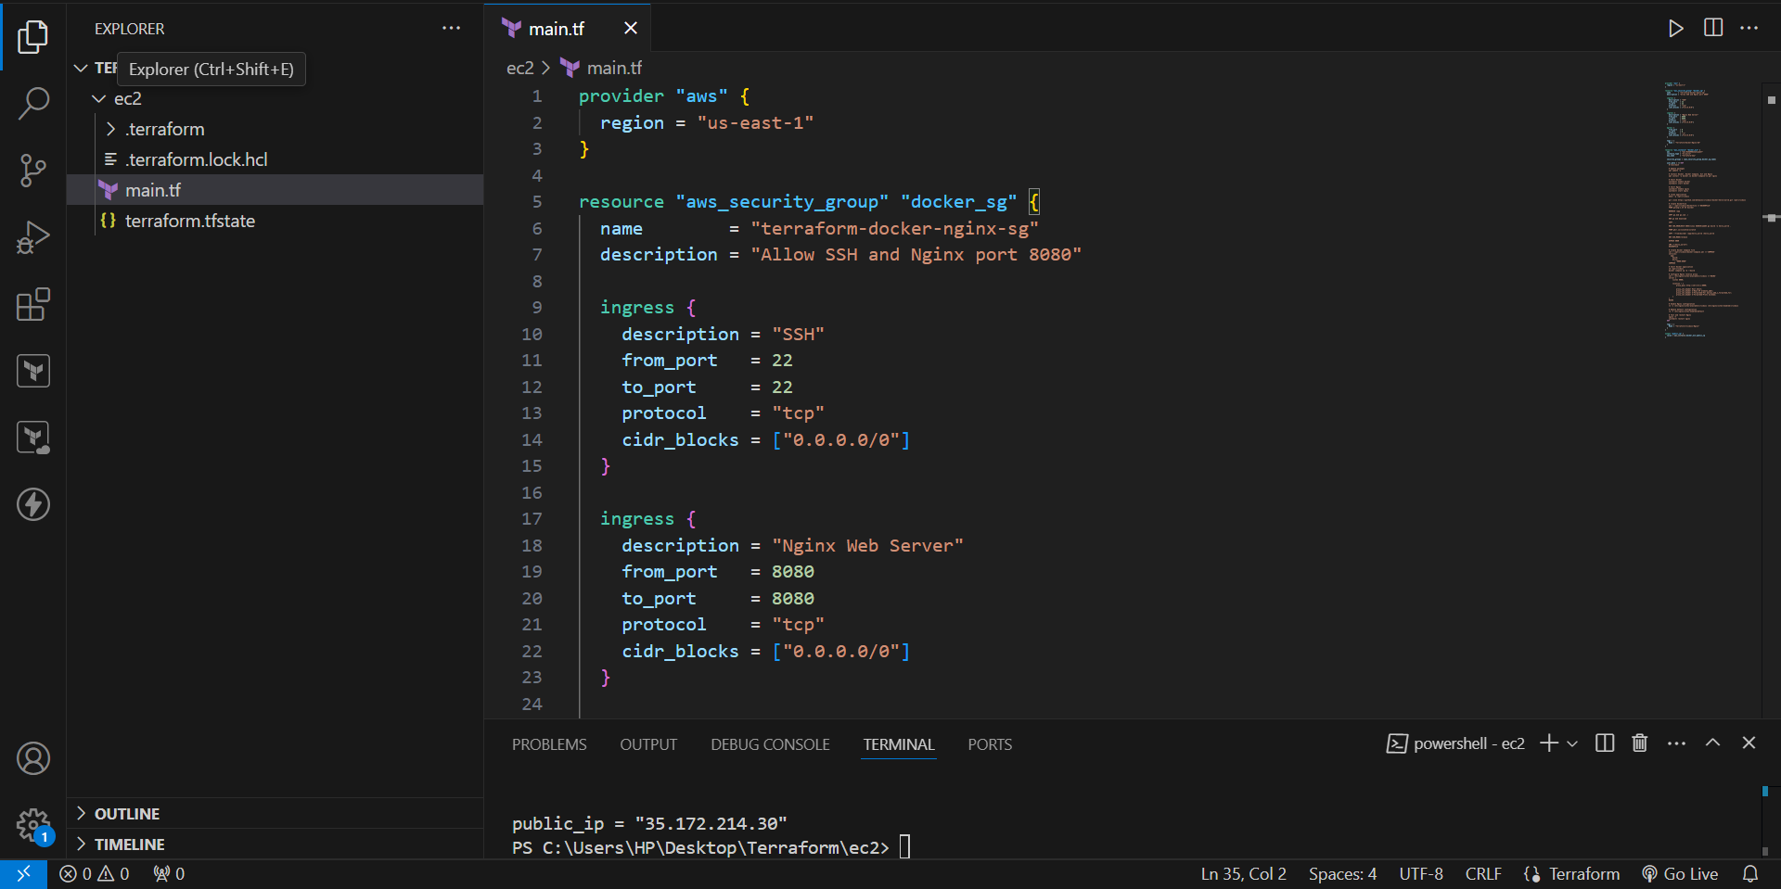
Terraform Commands
From your Terraform directory:
Initialize
terraform init
Format
terraform fmt
Validate
terraform validate
Expected:
Success! The configuration is valid.
Plan
terraform plan
Review the changes.
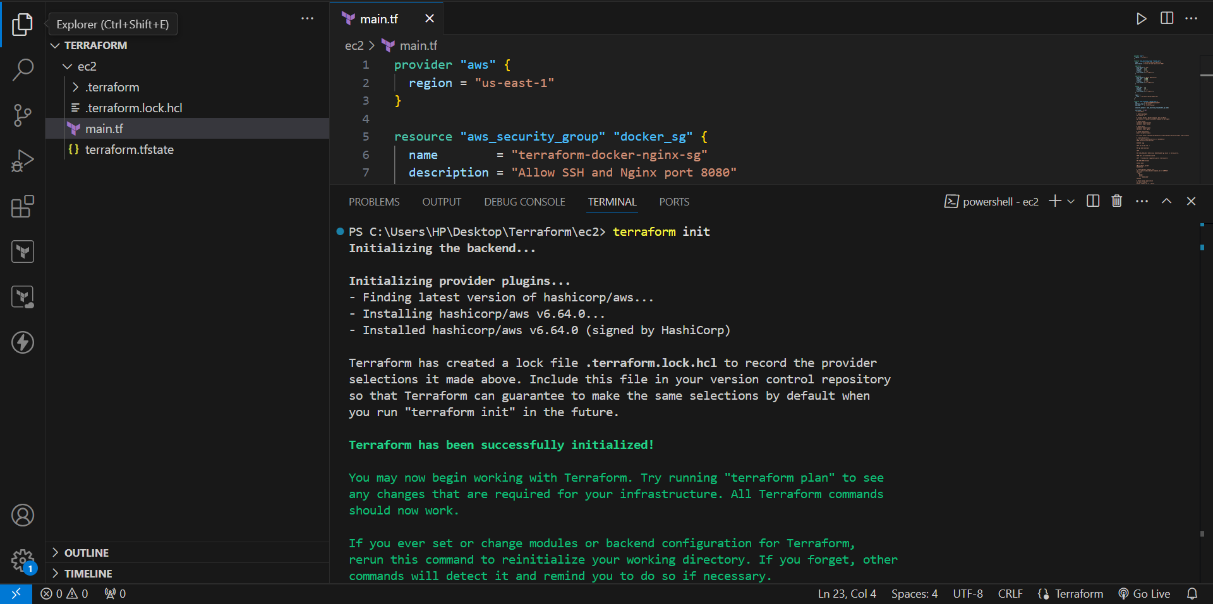
Apply
terraform apply
Enter:
yes
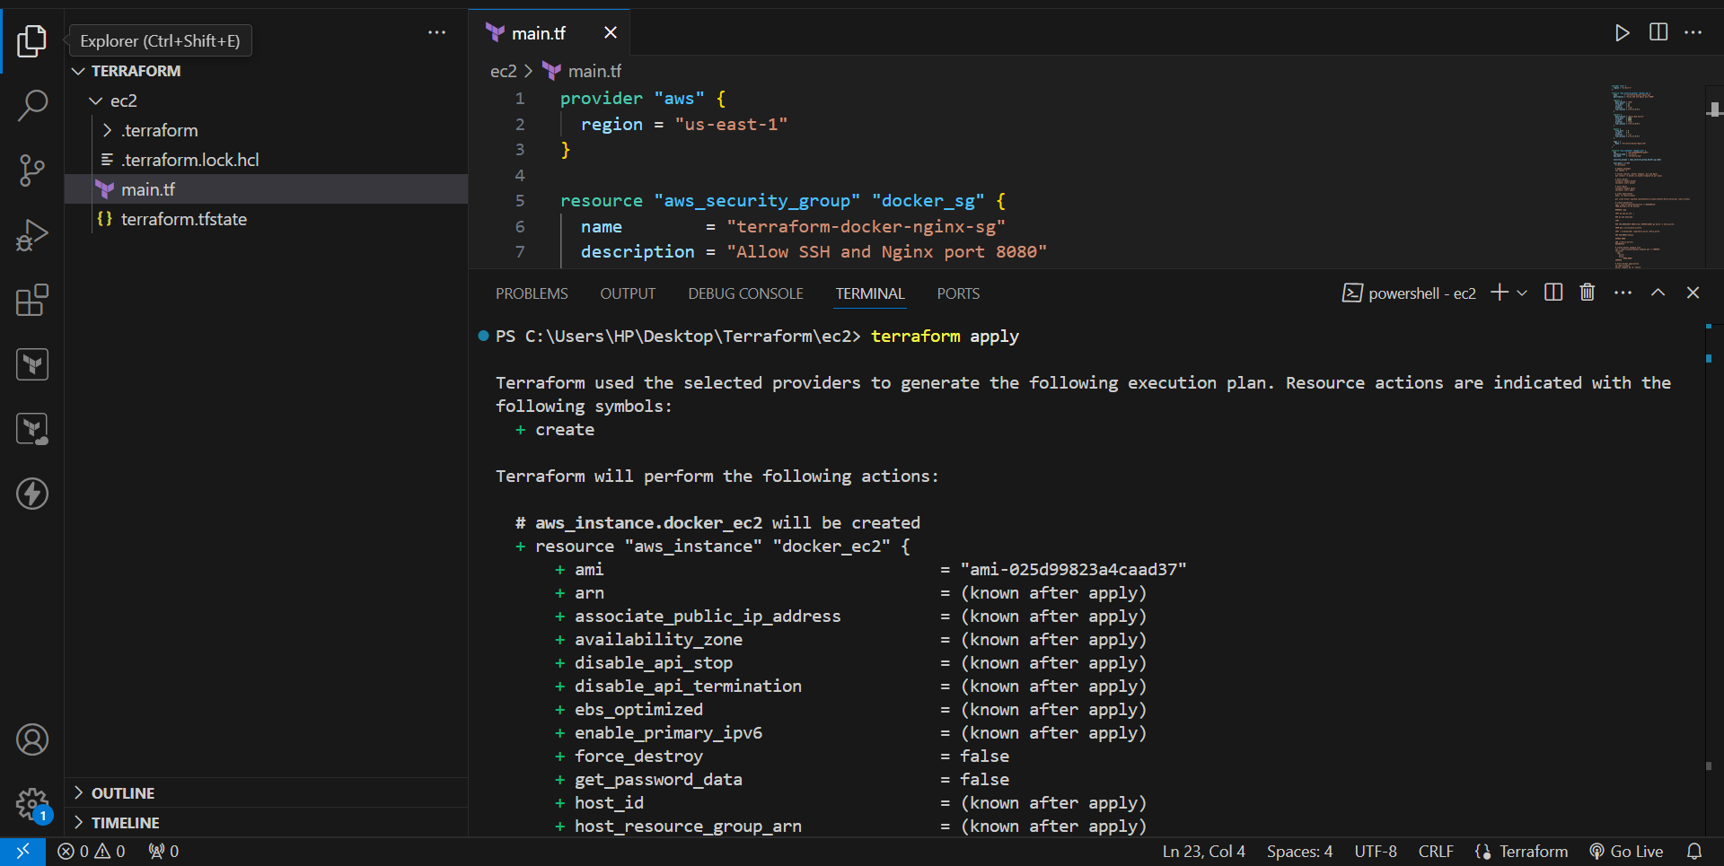
SSH into EC2
ssh -i "C:/Users/HP/Downloads/Terraform-key.pem" ubuntu@52.200.3.178
Use your actual IP.

Step 8: Verify Docker
docker ps
You should see:
cricbuzz-app-1
Check Compose:
cd /opt/cricbuzz
docker compose ps
You should see:
0.0.0.0:8000->8080/tcp
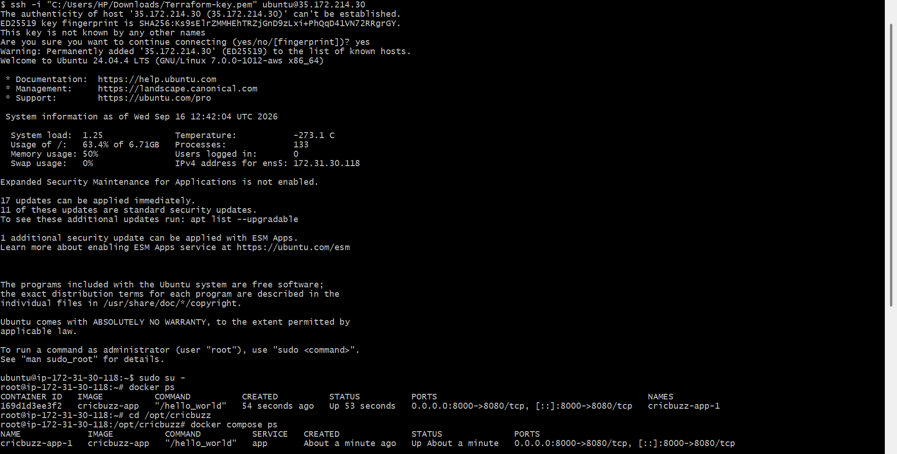
Verify Nginx
Run:
systemctl status nginx
You want:
Active: active (running)
Then:
nginx -t
Expected:
syntax is ok
test is successful
Test the Docker Service Directly
First test the existing Docker service:
curl http://localhost:8000
Expected:
Hello, World!
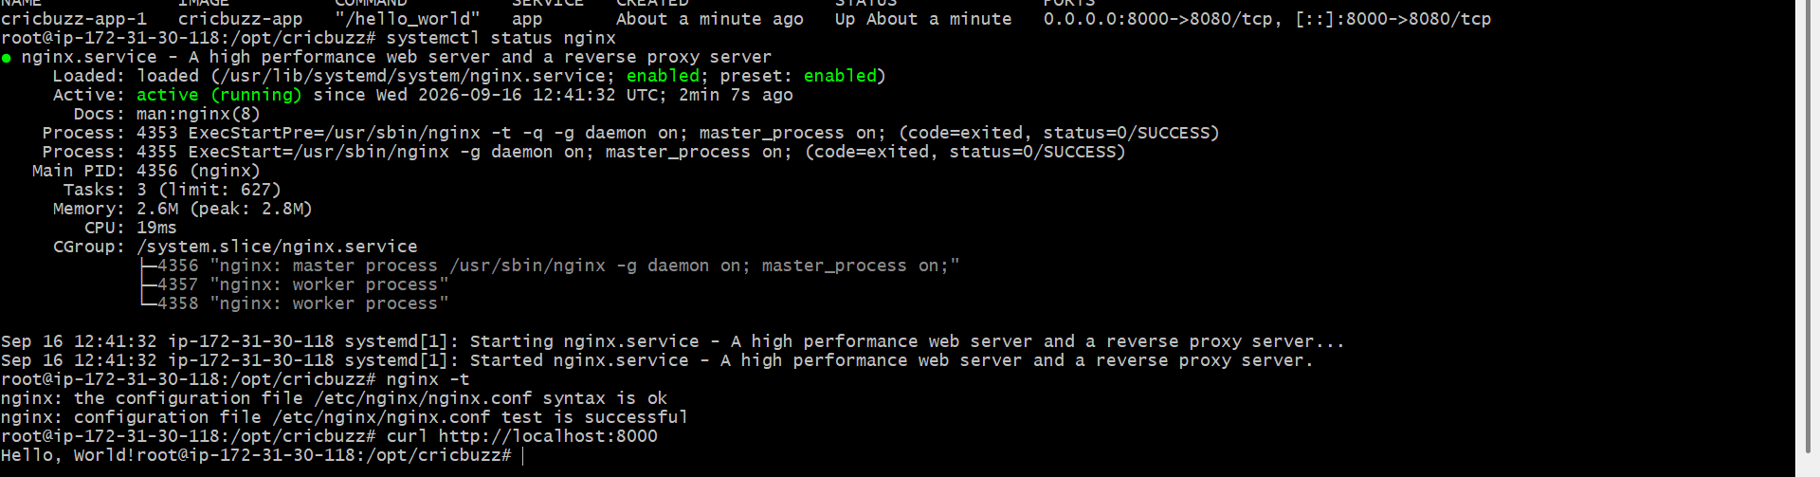
Test from Browser
Open:
http://52.200.3.178:8080
You should see:
Hello, World!
Configure to Save the Logs in the location /var/log/cb.log
Create Terraform Directory
Create a directory for the project.
mkdir cricbuzz-terraform
Go inside the directory:
cd cricbuzz-terraform
Create the Terraform file:
Create main.tf
Add the following Terraform code:
terraform {
required_providers {
aws = {
source = "hashicorp/aws"
version = "~> 6.0"
}
}
}

provider "aws" {
region = "us-east-1"
}

resource "aws_security_group" "cricbuzz_sg" {
name = "cricbuzz-nginx-sg"
description = "Allow SSH and Nginx"

ingress {
description = "SSH"
from_port = 22
to_port = 22
protocol = "tcp"
cidr_blocks = ["0.0.0.0/0"]
}

ingress {
description = "Nginx"
from_port = 8080
to_port = 8080
protocol = "tcp"
cidr_blocks = ["0.0.0.0/0"]
}

egress {
from_port = 0
to_port = 0
protocol = "-1"
cidr_blocks = ["0.0.0.0/0"]
}
}

resource "aws_instance" "cricbuzz" {

ami = "ami-0332d564d76dbd8d6"
instance_type = "t3.micro"
key_name = "Northvirginia-key"

vpc_security_group_ids = [
aws_security_group.cricbuzz_sg.id
]

user_data = <<-EOF
#!/bin/bash

# Update packages
apt-get update -y

# Install Nginx
apt-get install -y nginx

# Create Nginx configuration
cat > /etc/nginx/sites-available/cricbuzz <<'NGINX'
server {
listen 8080;

access_log /var/log/cb.log;
error_log /var/log/cb-error.log;

location / {
proxy_pass http://127.0.0.1:8000;

proxy_set_header Host $host;
proxy_set_header X-Real-IP $remote_addr;
proxy_set_header X-Forwarded-For $proxy_add_x_forwarded_for;
proxy_set_header X-Forwarded-Proto $scheme;
}
}
NGINX

# Enable Cricbuzz configuration
ln -sf /etc/nginx/sites-available/cricbuzz /etc/nginx/sites-enabled/cricbuzz

# Remove default Nginx configuration
rm -f /etc/nginx/sites-enabled/default

# Test Nginx configuration
nginx -t

# Enable and restart Nginx
systemctl enable nginx
systemctl restart nginx

EOF

tags = {
Name = "Cricbuzz-Nginx-Server"
}
}
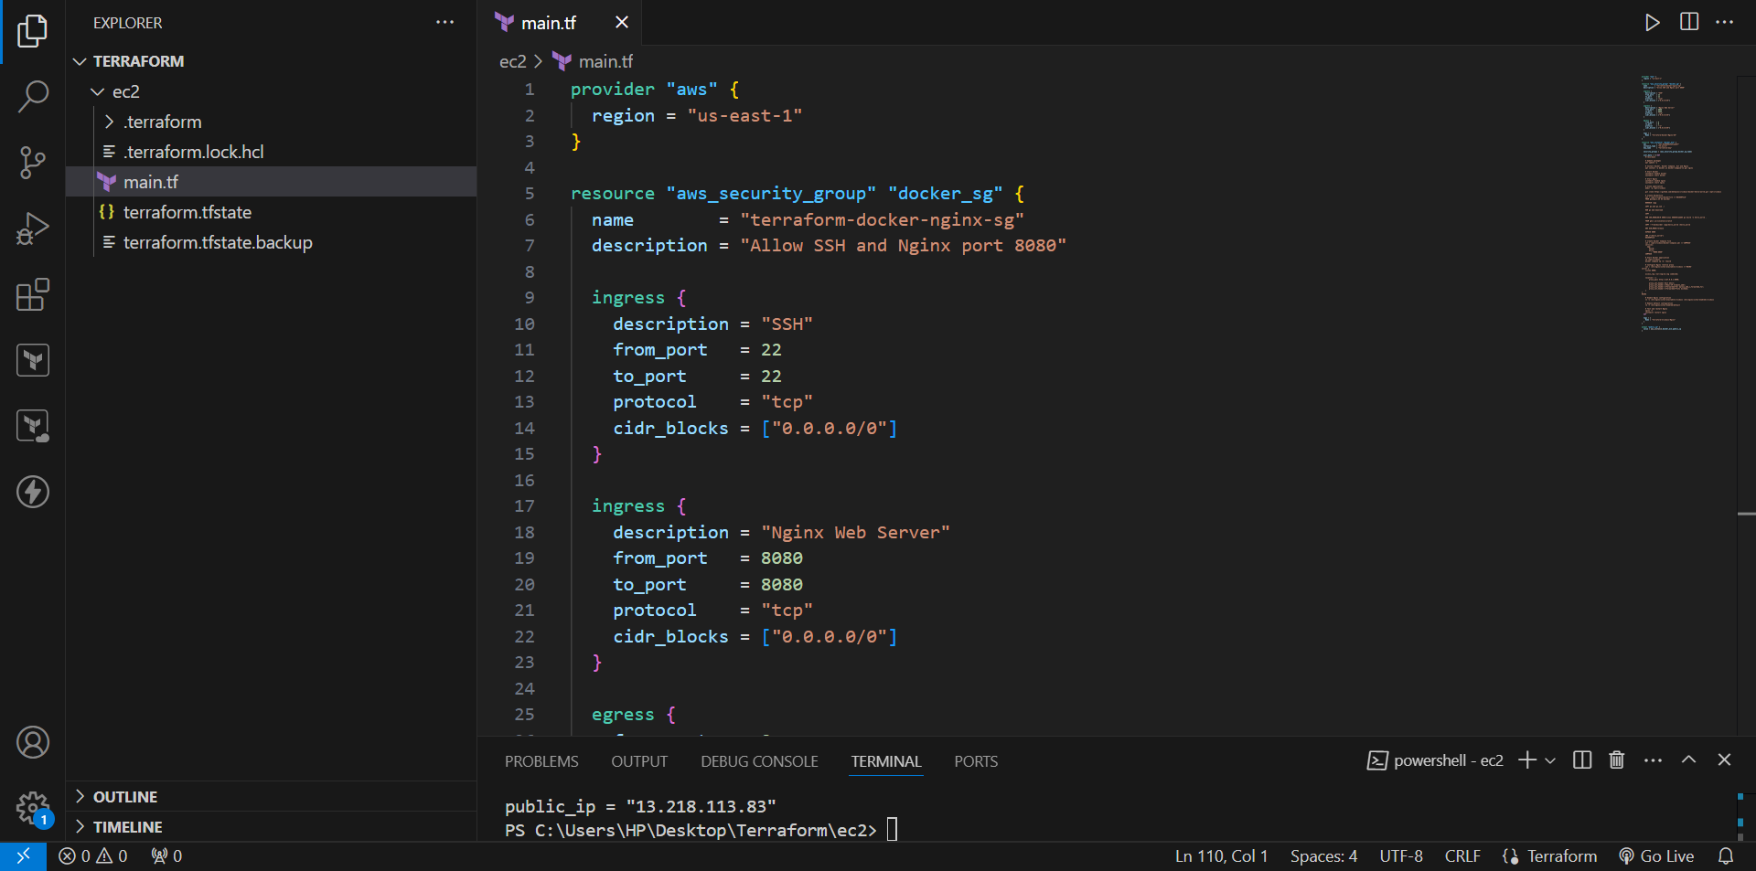
Initialize Terraform
Run:
terraform init
Expected:
Terraform has been successfully initialized!

10. Validate Terraform Configuration
Run:
terraform validate
Expected:
Success! The configuration is valid.

11. Format Terraform Code
Run:
terraform fmt
This formats the Terraform configuration.

12. Create Terraform Plan
Run:
terraform plan
Review the resources Terraform is going to create.
You should see resources such as:
aws_security_group.cricbuzz_sg
aws_instance.cricbuzz

13. Create the Infrastructure
Run:
terraform apply
Terraform will ask:
Do you want to perform these actions?
Enter:
yes
Terraform will create the EC2 instance.
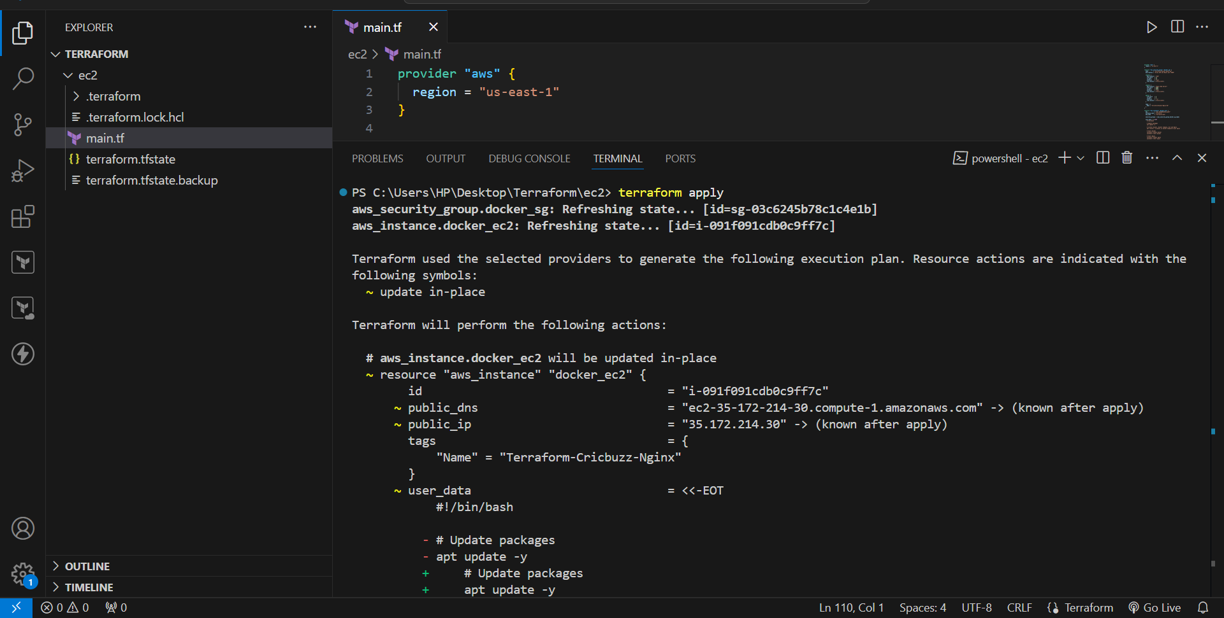
Get the EC2 Public IP
After terraform apply, go to:
AWS Console → EC2 → Instances
Find:
Cricbuzz-Nginx-Server
Copy the Public IPv4 address.

15. Connect to the EC2 Instance
From your local machine:
ssh -i Northvirginia-key.pem ubuntu@<PUBLIC-IP>
Replace <PUBLIC-IP> with your actual EC2 public IP.

16. Verify Nginx
Check Nginx status:
systemctl status nginx
You should see:
Active: active (running)

17. Verify Nginx Configuration
Run:
cat /etc/nginx/sites-available/cricbuzz
You should see:
server {
listen 8080;

access_log /var/log/cb.log;
error_log /var/log/cb-error.log;

location / {
proxy_pass http://127.0.0.1:8000;

proxy_set_header Host $host;
proxy_set_header X-Real-IP $remote_addr;
proxy_set_header X-Forwarded-For $proxy_add_x_forwarded_for;
proxy_set_header X-Forwarded-Proto $scheme;
}
}
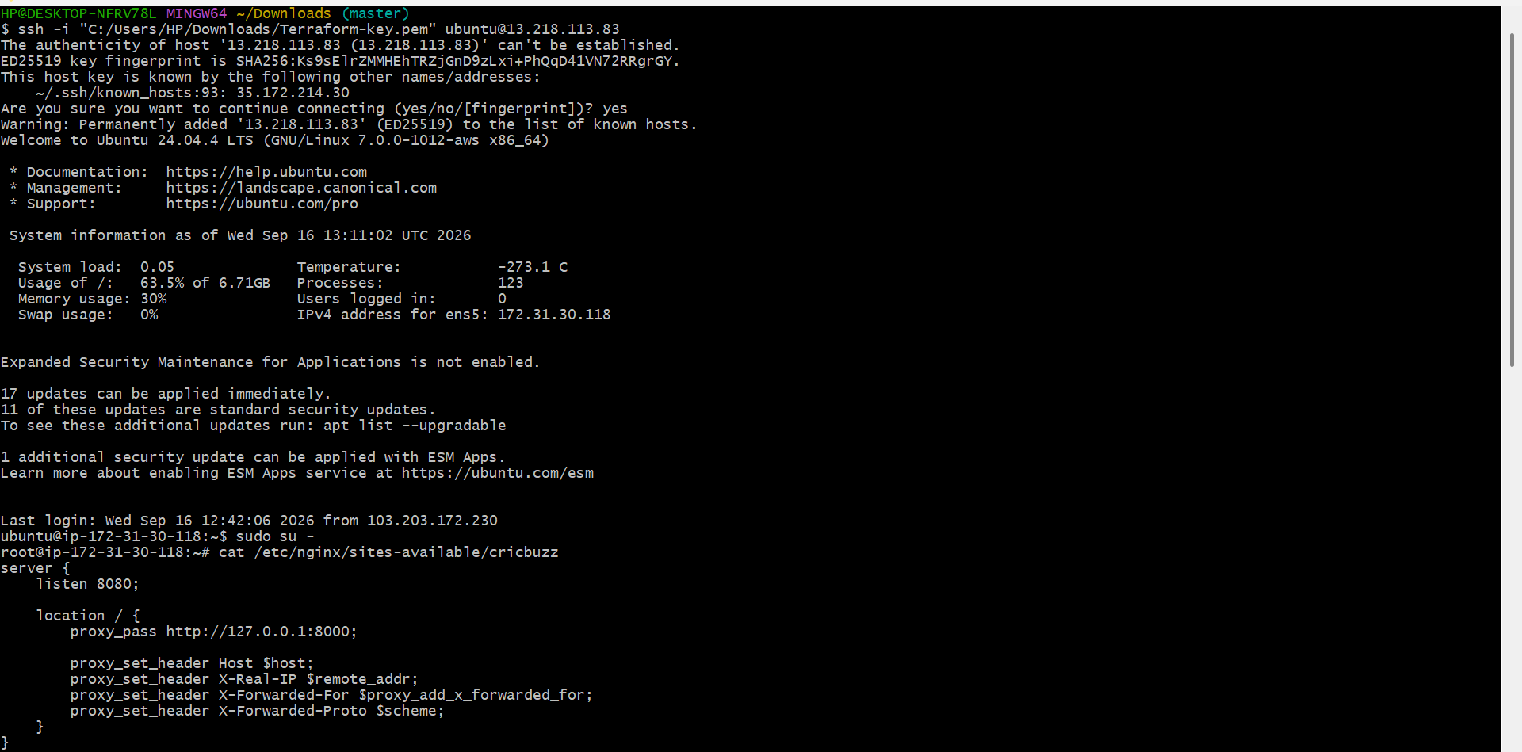
Verify the Log File
Run:
ls -l /var/log/cb.log
The file should exist:
/var/log/cb.log

19. Start the Docker Application
If the Docker image is available on the EC2 instance, run:
docker run -d --name cricbuzz -p 8000:8080 cricbuzz-app:latest
Verify:
docker ps
Expected:
cricbuzz-app:latest
0.0.0.0:8000->8080/tcp
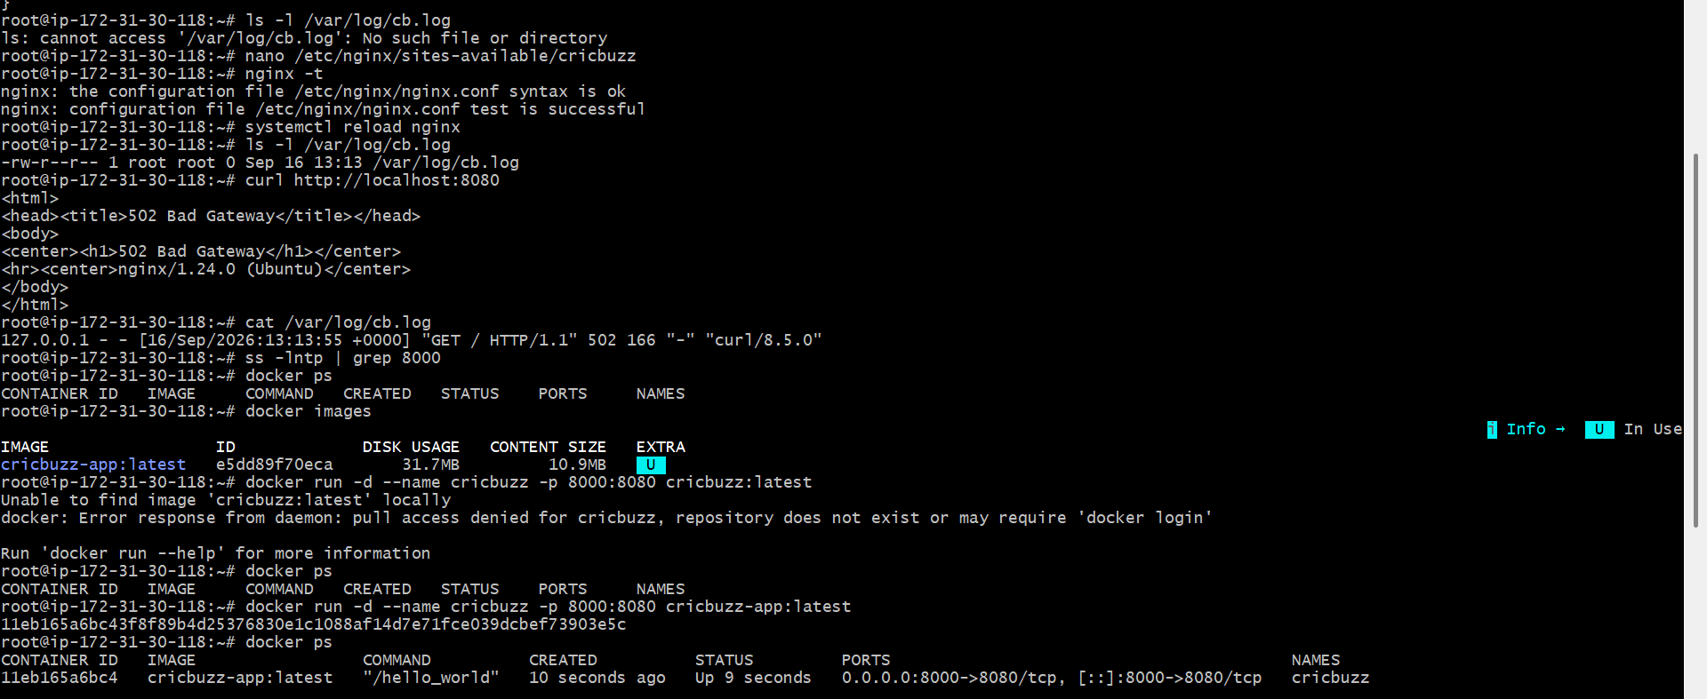
Test the Application
First test Docker directly:
curl http://localhost:8000
Expected:
Hello, World!
This confirms that the application is running.

Test Nginx Reverse Proxy
Now test Nginx:
curl http://localhost:8080
Expected:
Hello, World!
This confirms:
Nginx :8080
↓
127.0.0.1:8000
↓
Docker Application
is working.

Test from Browser
Open your browser and enter:
http://<PUBLIC-IP>:8080
Expected:
Hello, World!
Then check the log again:
cat /var/log/cb.log
The browser request should now appear in the log.
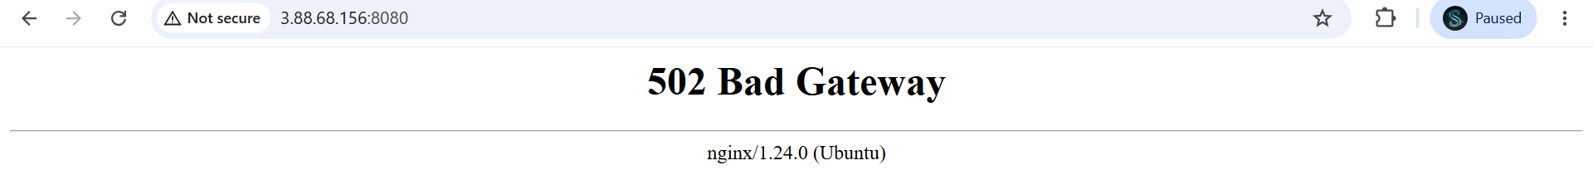
Write the Log rotate configuration for the above file
Create Terraform Project
Create a Terraform directory.
Example:
mkdir C:\Users\HP\Desktop\Terraform\ec2
Move into the directory:
cd C:\Users\HP\Desktop\Terraform\ec2
Create a file:
main.tf
The Terraform configuration will be stored in this file.

4. Configure AWS Provider
The AWS provider tells Terraform to use AWS.
terraform {
required_providers {
aws = {
source = "hashicorp/aws"
version = "~> 6.0"
}
}
}

provider "aws" {
region = "us-east-1"
}

5. Create Security Group
The security group allows:
- SSH → Port 22
- Nginx → Port 8080
- Outbound traffic → All
resource "aws_security_group" "cricbuzz_sg" {
name = "cricbuzz-nginx-sg"
description = "Allow SSH and Nginx"

ingress {
description = "SSH"
from_port = 22
to_port = 22
protocol = "tcp"
cidr_blocks = ["0.0.0.0/0"]
}

ingress {
description = "Nginx"
from_port = 8080
to_port = 8080
protocol = "tcp"
cidr_blocks = ["0.0.0.0/0"]
}

egress {
from_port = 0
to_port = 0
protocol = "-1"
cidr_blocks = ["0.0.0.0/0"]
}
}
For a real production environment, SSH access should normally be restricted to trusted IP addresses rather than 0.0.0.0/0.

6. Create IAM Role
The EC2 instance needs permission to access the private ECR repository.
Create an IAM role:
resource "aws_iam_role" "cricbuzz_ec2_role" {
name = "cricbuzz-ec2-ecr-role"

assume_role_policy = jsonencode({
Version = "2012-10-17"

Statement = [
{
Effect = "Allow"

Principal = {
Service = "ec2.amazonaws.com"
}

Action = "sts:AssumeRole"
}
]
})
}
Why do we need IAM?
The EC2 instance needs permission to:
Login to ECR
↓
Pull Docker image
↓
Run Docker container

7. Attach ECR Read-Only Policy
Attach the AWS-managed ECR read-only policy:
resource "aws_iam_role_policy_attachment" "ecr_read_only" {
role = aws_iam_role.cricbuzz_ec2_role.name

policy_arn = "arn:aws:iam::aws:policy/AmazonEC2ContainerRegistryReadOnly"
}
This allows the EC2 instance to read and pull images from ECR.

8. Create IAM Instance Profile
The instance profile allows the IAM role to be attached to EC2.
resource "aws_iam_instance_profile" "cricbuzz_instance_profile" {
name = "cricbuzz-ec2-instance-profile"

role = aws_iam_role.cricbuzz_ec2_role.name
}

9. Create EC2 Instance
Create the EC2 instance:
resource "aws_instance" "cricbuzz" {

ami = "ami-0332d564d76dbd8d6"
instance_type = "t3.micro"
key_name = "Terraform-key"

vpc_security_group_ids = [
aws_security_group.cricbuzz_sg.id
]

iam_instance_profile = aws_iam_instance_profile.cricbuzz_instance_profile.name
The IAM instance profile connects the EC2 instance to the IAM role.

10. Install Required Software Using User Data
Terraform user_data automatically executes commands when the EC2 instance starts for the first time.
We install:
- Docker
- Nginx
- Logrotate
- AWS CLI
dnf update -y

dnf install -y docker nginx logrotate awscli

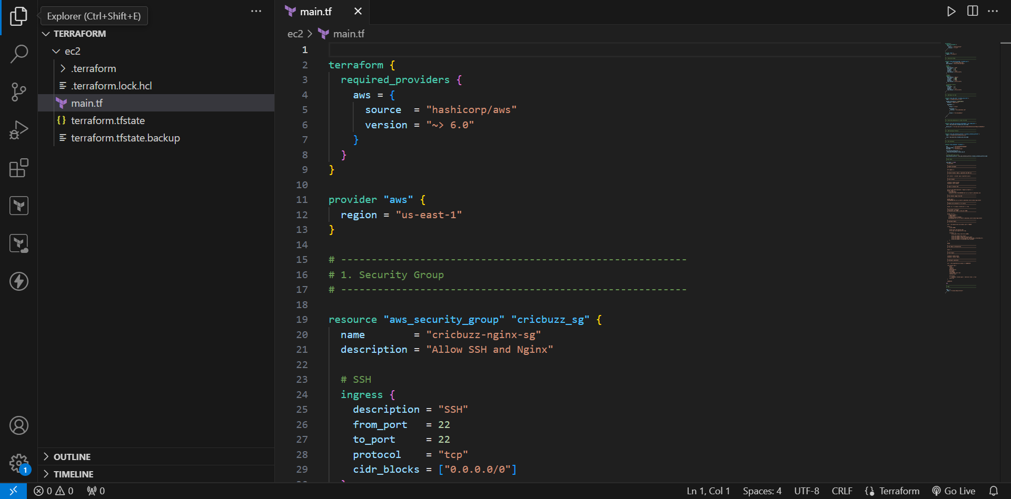
Start Docker
Enable Docker to start automatically:
systemctl enable docker
systemctl start docker
Verify:
systemctl status docker
Expected:
active (running)
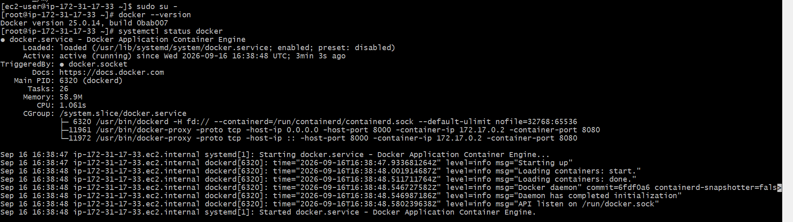
Login to Amazon ECR
The EC2 instance uses its IAM role to authenticate with ECR.
aws ecr get-login-password --region us-east-1 | \
docker login \
--username AWS \
--password-stdin 934140896884.dkr.ecr.us-east-1.amazonaws.com
Pull Docker Image from ECR
Pull the Cricbuzz application image:
docker pull \
934140896884.dkr.ecr.us-east-1.amazonaws.com/cricbuzz-app:latest
Verify:
docker images
The ECR image should be displayed.

14. Run Docker Container
Run the application:
docker run -d \
--name cricbuzz \
-p 8000:8080 \
--restart unless-stopped \
934140896884.dkr.ecr.us-east-1.amazonaws.com/cricbuzz-app:latest
Port Mapping
EC2 Host
Port 8000
|
v
Docker Container
Port 8080
Check the container:
docker ps
Expected:
0.0.0.0:8000->8080/tcp
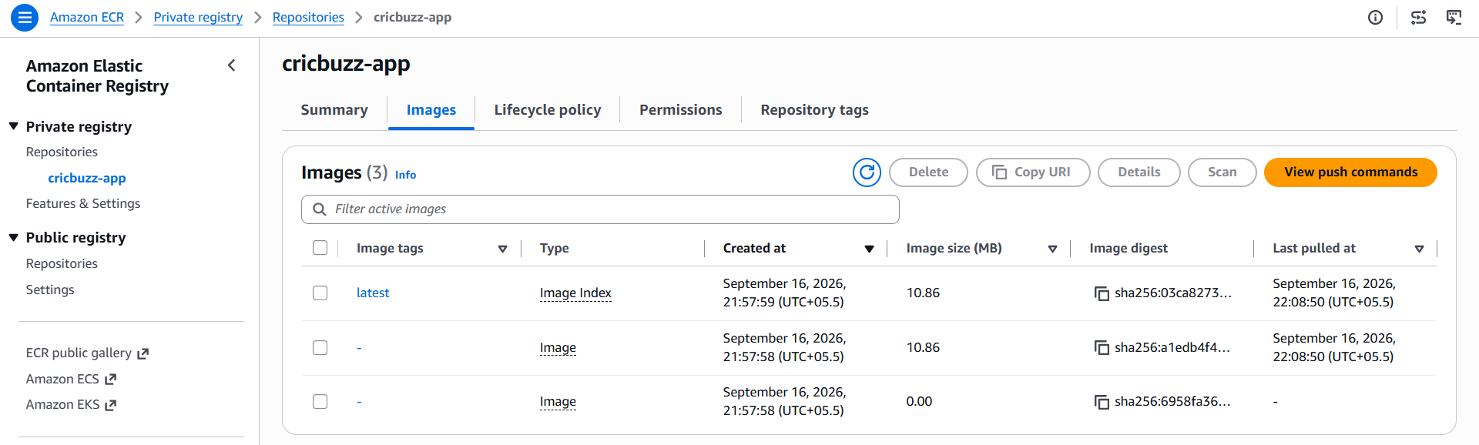
Test Docker Application
Run:
curl http://localhost:8000
Expected output:
Hello, World!
This confirms that the Docker application is working.
Configure Nginx
Create the Nginx configuration:
/etc/nginx/conf.d/cricbuzz.conf
Configuration:
server {
listen 8080;

access_log /var/log/cb.log;
error_log /var/log/cb-error.log;

location / {
proxy_pass http://127.0.0.1:8000;

proxy_set_header Host $host;
proxy_set_header X-Real-IP $remote_addr;
proxy_set_header X-Forwarded-For $proxy_add_x_forwarded_for;
proxy_set_header X-Forwarded-Proto $scheme;
}
}
Configure Logrotate
Create:
/etc/logrotate.d/cricbuzz
Configuration:
/var/log/cb.log {
daily
rotate 7
compress
delaycompress
missingok
notifempty
create 0640 root root
sharedscripts

postrotate
systemctl reload nginx > /dev/null 2>&1 || true
endscript
}
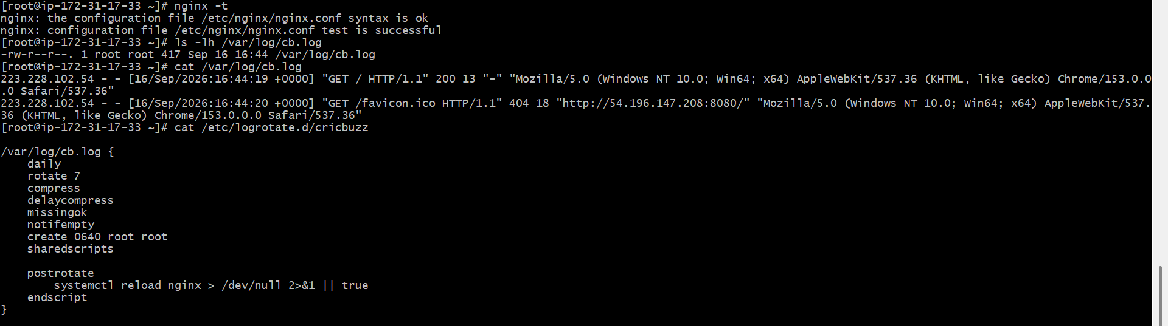
Start Nginx
Enable Nginx:
systemctl enable nginx
Start/restart Nginx:
systemctl restart nginx
Check status:
systemctl status nginx
Expected:
active (running)

20. Test Nginx
Run:
curl http://localhost:8080
Expected:
Hello, World!
This confirms:
Nginx → Docker → Application
is working.
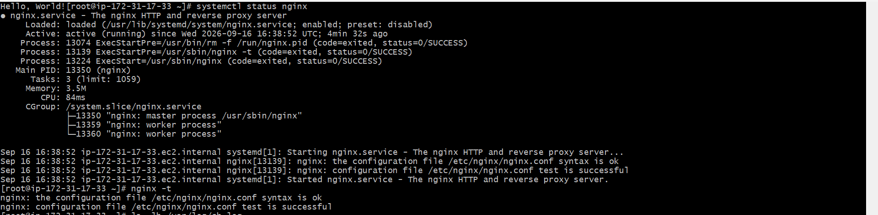
Verify IAM from EC2
After connecting to the EC2 instance, you can verify that AWS credentials are being provided through the IAM role.
Run:
aws sts get-caller-identity
You should get output containing an ARN similar to:
Arn: arn:aws:sts::934140896884:assumed-role/cricbuzz-ec2-ecr-role/...
The important part is:
cricbuzz-ec2-ecr-role
This confirms that the EC2 instance is using the IAM Role.
